* **Mobile Application Development Lab**

1. Creating “Hello world” Application.
2. Creating an application that displays message based on the screen orientation.
3. Create an application to develop Login window using UI controls.
4. Create an application to implement new activity using explicit intent, implicit intent and content provider.
5. Create an application that displays custom designed Opening Screen.
6. Create an UI with all views.
7. Create menu in Application
8. Read/ write the Local data.
9. Create / Read / Write data with database (SQLite).
10. Create an application to send SMS and receive SMS
11. Create an application to send an e-mail.
12. Display Map based on the Current/given location.
13. Create a sample application with login module(check user name and password) On successful login change Textview “Login Successful”. On login fail alert using Toast “login fail”
14. Learn to deploy Android applications

**Program 1**

Creating “Hello world” Application.

*<?*xml version="1.0" encoding="utf-8"*?>*

<androidx.constraintlayout.widget.ConstraintLayout xmlns:andr[oid="htt](http://schemas.android.com/apk/res/android)p:/[/sc](http://schemas.android.com/apk/res/android)he[mas.android.com/apk/res/android"](http://schemas.android.com/apk/res/android)

xmlns:app=["http://sc](http://schemas.android.com/apk/res-auto)h[emas.android.com/apk/res-auto"](http://schemas.android.com/apk/res-auto) xmlns:t[ools="ht](http://schemas.android.com/tools)tp:/[/sc](http://schemas.android.com/tools)he[mas.android.com/tools"](http://schemas.android.com/tools) android:layout_width="match_parent" android:layout_height="match_parent" tools:context=".MainActivity">

<Button

**android:id="@+id/hello"** android:layout_width="wrap_content" android:layout_height="wrap_content" **android:background="#535538" android:text="Click Me!"** app:layout_constraintBottom_toBottomOf="parent" app:layout_constraintEnd_toEndOf="parent" app:layout_constraintStart_toStartOf="parent" app:layout_constraintTop_toTopOf="parent" />

</androidx.constraintlayout.widget.ConstraintLayout>

package com.example.hello_world;

import androidx.appcompat.app.AppCompatActivity; import android.os.Bundle;

import android.view.View; import android.widget.Button; import android.widget.Toast;

public class MainActivity extends AppCompatActivity { @Override

protected void onCreate(Bundle savedInstanceState) { super.onCreate(savedInstanceState); setContentView(R.layout.*activity_main*);

**Button b; b=findViewById(R.id.*hello*);**

**b.setOnClickListener(new View.OnClickListener() { @Override**

**public void onClick(View v) {**

**Toast.*makeText*(MainActivity.this, "Hey! We are using Android Application", Toast.*LENGTH_SHORT*).show();**

}

});

}

}

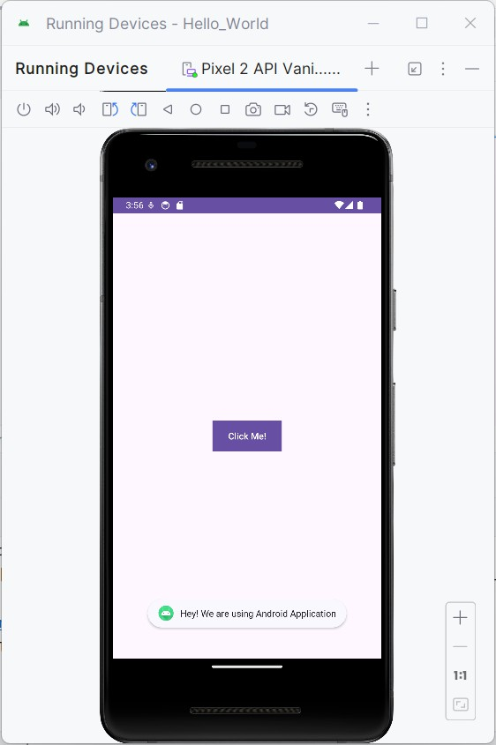**Output:**

**Program 2:**

Creating an application that displays message based on the screen orientation

<?xml version="1.0" encoding="utf-8"?>

<RelativeLayout xmlns:android=["http://schemas.android.com/](http://schemas.android.com/apk/res/android)a[pk/res/android"](http://schemas.android.com/apk/res/android) xmlns:app=["http://sc](http://schemas.android.com/apk/res-auto)h[emas.android.com/apk/res-auto"](http://schemas.android.com/apk/res-auto) xmlns:t[ools="ht](http://schemas.android.com/tools)tp:/[/sc](http://schemas.android.com/tools)he[mas.android.com/tools"](http://schemas.android.com/tools)

android:id="@+id/main" android:layout_width="match_parent" android:layout_height="match_parent" tools:context=".MainActivity">

<Button

android:id="@+id/por" android:layout_width="wrap_content" android:layout_height="wrap_content" android:text="Portrait" android:layout_centerInParent="true"/>

<Button

android:id="@+id/lan" android:layout_width="wrap_content" android:layout_height="wrap_content" android:text="Landscape" android:layout_below="@id/por" android:layout_centerInParent="true"/>

</RelativeLayout>

package com.example.screen;

import android.content.pm.ActivityInfo; import android.os.Bundle;

import android.view.View; import android.widget.Button; import android.widget.Toast;

import androidx.activity.EdgeToEdge;

import androidx.appcompat.app.AppCompatActivity; import androidx.core.graphics.Insets;

import androidx.core.view.ViewCompat;

import androidx.core.view.WindowInsetsCompat; public class MainActivity extends AppCompatActivity {

@Override

protected void onCreate(Bundle savedInstanceState) { super.onCreate(savedInstanceState); EdgeToEdge.enable(this); setContentView(R.layout.activity_main);

Button l,p; l=findViewById(R.id.*lan*); p=findViewById(R.id.*por*);

l.setOnClickListener(new View.OnClickListener() { @Override

public void onClick(View v) {

setRequestedOrientation(ActivityInfo.*SCREEN_ORIENTATION_LANDSCAPE*);

Toast.*makeText*(MainActivity.this, "Hey! We are in Landscape orientation", Toast.*LENGTH_SHORT*).show();

}

});

p.setOnClickListener(new View.OnClickListener() { @Override

public void onClick(View v) {

setRequestedOrientation(ActivityInfo.*SCREEN_ORIENTATION_PORTRAIT*); Toast.*makeText*(MainActivity.this, "Hey! We are in Portrait orientation",

Toast.*LENGTH_SHORT*).show();

}

});

}

}

**Output**

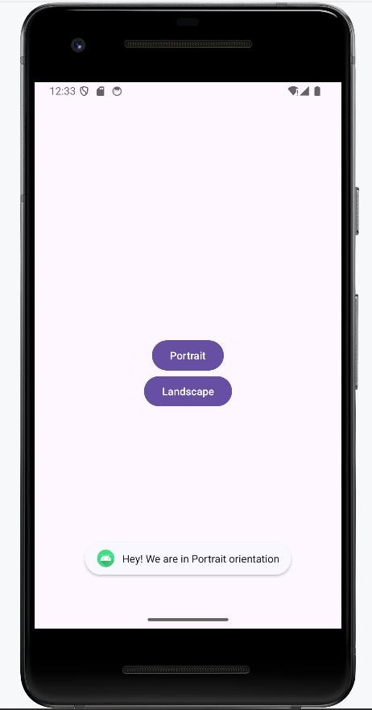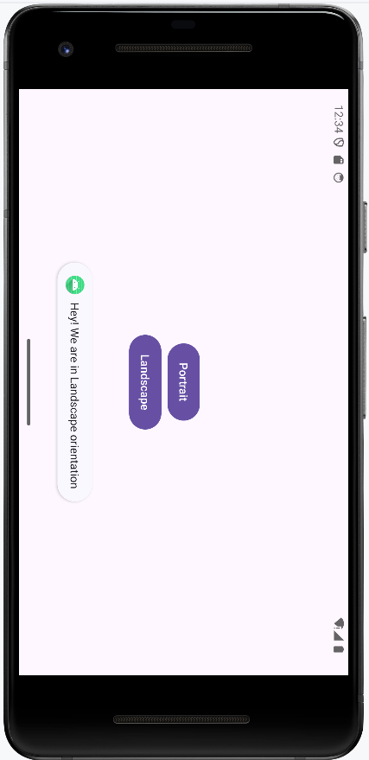

**Program 3**

Create an application to develop Login window using UI controls.

<?xml version="1.0" encoding="utf-8"?>

<RelativeLayout xmlns:android=["http://schemas.android.com/](http://schemas.android.com/apk/res/android)a[pk/res/android"](http://schemas.android.com/apk/res/android) xmlns:app=["http://sc](http://schemas.android.com/apk/res-auto)h[emas.android.com/apk/res-auto"](http://schemas.android.com/apk/res-auto) xmlns:t[ools="ht](http://schemas.android.com/tools)tp:/[/sc](http://schemas.android.com/tools)he[mas.android.com/tools"](http://schemas.android.com/tools)

android:id="@+id/main" android:layout_width="match_parent" android:layout_height="match_parent" tools:context=".MainActivity" android:background="@drawable/bg_outer">

<LinearLayout android:layout_width="match_parent" android:layout_height="wrap_content" android:gravity="center" android:layout_centerInParent="true" android:orientation="vertical" android:background="@drawable/bg_inner" android:padding="30dp">

<TextView

android:layout_width="wrap_content"

android:layout_height="wrap_content"

android:text="LOGIN PAGE"

android:textSize="32sp"

android:textStyle="bold"

android:fontFamily="sans-serif-condensed-medium" android:textColor="@color/black" android:paddingBottom="20dp"/>

<EditText android:id="@+id/editTextUsername" android:layout_width="match_parent"

android:layout_height="wrap_content" android:hint="Username" android:layout_marginBottom="16dp"/>

<EditText android:id="@+id/editTextPassword" android:layout_width="match_parent" android:layout_height="wrap_content" android:hint="Password"

android:layout_below="@id/editTextUsername" android:layout_marginBottom="16dp" android:inputType="textPassword"/>

<Button

android:id="@+id/buttonLogin" android:layout_width="wrap_content" android:layout_height="wrap_content" android:text="Login" android:layout_below="@id/editTextPassword"/>

</LinearLayout>

</RelativeLayout>

package com.example.controls;

import android.os.Bundle; import android.view.View; import android.widget.Button; import android.widget.EditText; import android.widget.Toast;

import androidx.activity.EdgeToEdge;

import androidx.appcompat.app.AppCompatActivity; import androidx.core.graphics.Insets;

import androidx.core.view.ViewCompat;

import androidx.core.view.WindowInsetsCompat;

public class MainActivity extends AppCompatActivity { private EditText editTextUsername,editTextPassword; private Button buttonLogin;

@Override

protected void onCreate(Bundle savedInstanceState) { super.onCreate(savedInstanceState); EdgeToEdge.enable(this); setContentView(R.layout.activity_main);

editTextUsername = findViewById(R.id.*editTextUsername*); editTextPassword = findViewById(R.id.*editTextPassword*); buttonLogin = findViewById(R.id.*buttonLogin*); buttonLogin.setOnClickListener(new View.OnClickListener() {

@Override

public void onClick(View v) {

String username = editTextUsername.getText().toString().trim(); String password = editTextPassword.getText().toString().trim();

if(username.equals("admin") && password.equals("pass")){ Toast.*makeText*(MainActivity.this, "Login successful",

Toast.*LENGTH_SHORT*).show();

} else {

Toast.*makeText*(MainActivity.this, "Invalid username or password", Toast.*LENGTH_SHORT*).show();

}

}

});

}

}

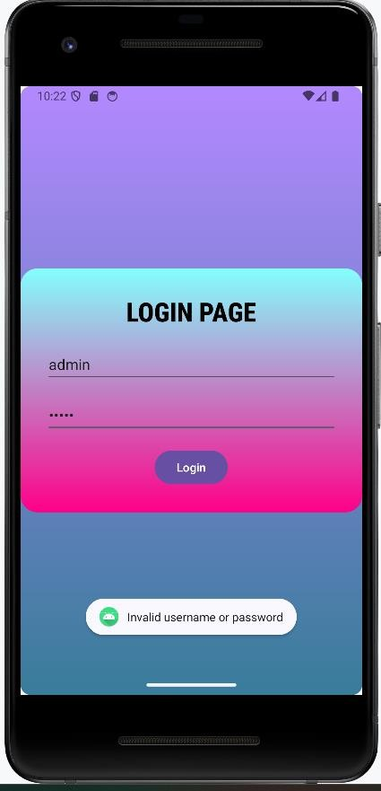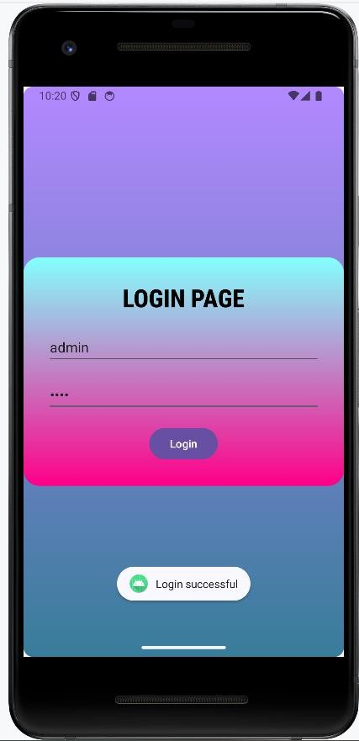

**Program 4:**

Create an application to implement new activity using explicit intent, implicit intent and content provider.

<?xml version="1.0" encoding="utf-8"?>

<androidx.constraintlayout.widget.ConstraintLayout xmlns:andr[oid="htt](http://schemas.android.com/apk/res/android)p:/[/sc](http://schemas.android.com/apk/res/android)he[mas.android.com/apk/res/android"](http://schemas.android.com/apk/res/android)

xmlns:app=["http://sc](http://schemas.android.com/apk/res-auto)h[emas.android.com/apk/res-auto"](http://schemas.android.com/apk/res-auto) xmlns:t[ools="ht](http://schemas.android.com/tools)tp:/[/sc](http://schemas.android.com/tools)he[mas.android.com/tools"](http://schemas.android.com/tools) android:id="@+id/main" android:layout_width="match_parent" android:layout_height="match_parent" tools:context=".NewActivity">

<TextView android:id="@+id/textView" android:layout_width="wrap_content"

android:layout_height="wrap_content" android:text="Welcome to Explicit Intent" android:textSize="28sp" app:layout_constraintBottom_toBottomOf="parent" app:layout_constraintEnd_toEndOf="parent" app:layout_constraintStart_toStartOf="parent" app:layout_constraintTop_toTopOf="parent" />

</androidx.constraintlayout.widget.ConstraintLayout>

package com.example.intentexample;

import android.content.Intent; import android.net.Uri; import android.os.Bundle; import android.view.View;

import androidx.activity.EdgeToEdge;

import androidx.appcompat.app.AppCompatActivity; import androidx.core.graphics.Insets;

import androidx.core.view.ViewCompat;

import androidx.core.view.WindowInsetsCompat; public class MainActivity extends AppCompatActivity{

@Override

protected void onCreate(Bundle savedInstanceState) {

super.onCreate(savedInstanceState);

EdgeToEdge.enable(this);

setContentView(R.layout.activity_main);

}

public void onImplicitButtonClicked(View view)

{

Uri url=Uri.*parse*("https://[www.google.com"](http://www.google.com/)); Intent i=new Intent(Intent.*ACTION_VIEW*, url); startActivity(i);

}

public void onExplicitButtonClicked(View view )

{

Intent i=new Intent(MainActivity.this, NewActivity.class); startActivity(i);

}

}

<?xml version="1.0" encoding="utf-8"?>

<LinearLayout xmlns:andr[oid="htt](http://schemas.android.com/apk/res/android)p:/[/schemas.android.com/](http://schemas.android.com/apk/res/android)a[pk/res/androi](http://schemas.android.com/apk/res/android)d" xmlns:app=["http://sc](http://schemas.android.com/apk/res-auto)h[emas.android.com/apk/res-auto"](http://schemas.android.com/apk/res-auto) xmlns:t[ools="ht](http://schemas.android.com/tools)tp:/[/sc](http://schemas.android.com/tools)he[mas.android.com/tools"](http://schemas.android.com/tools)

android:id="@+id/main" android:layout_width="match_parent" android:layout_height="match_parent" android:gravity="center" tools:context=".MainActivity">

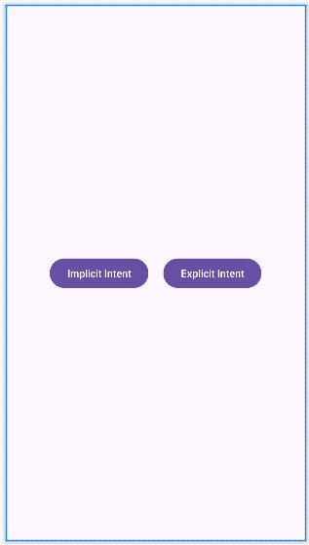<Button

android:layout_width="wrap_content" android:layout_height="wrap_content" android:text="Implicit Intent" android:onClick="onImplicitButtonClicked"/>

<Button

android:layout_width="wrap_content"

android:layout_height="wrap_content"

android:text="Explicit Intent"

android:onClick="onExplicitButtonClicked"/>

</LinearLayout>

**For Implicit Intent For Explicit Intent**

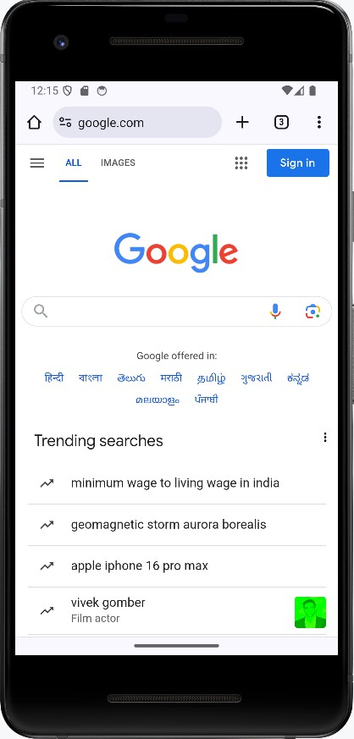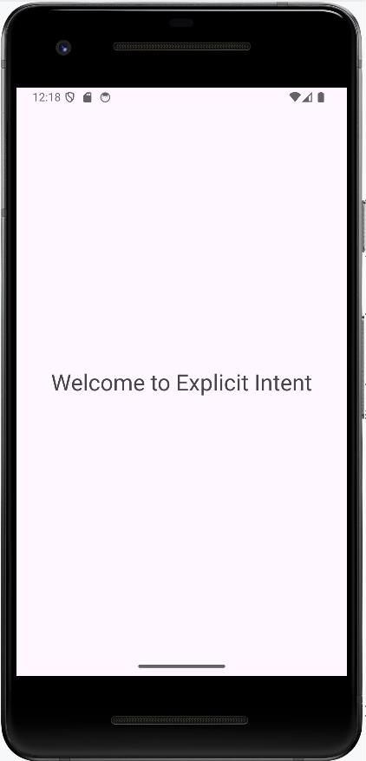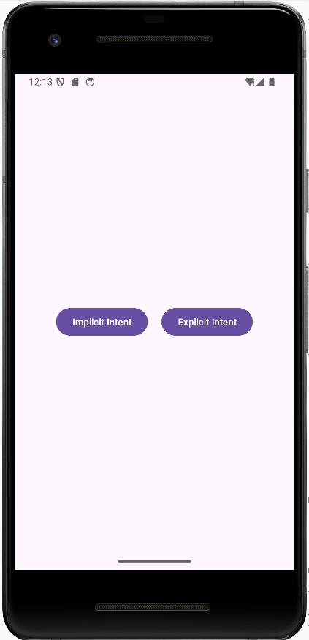

**Program 5:**

Create an application that displays custom designed Opening Screen.

*<?*xml version="1.0" encoding="utf-8"*?>*

<RelativeLayout xmlns:android=["http://schemas.android.com/](http://schemas.android.com/apk/res/android)a[pk/res/android"](http://schemas.android.com/apk/res/android) xmlns:app=["http://sc](http://schemas.android.com/apk/res-auto)h[emas.android.com/apk/res-auto"](http://schemas.android.com/apk/res-auto) xmlns:t[ools="ht](http://schemas.android.com/tools)tp:/[/sc](http://schemas.android.com/tools)he[mas.android.com/tools"](http://schemas.android.com/tools)

android:id="@+id/main" android:layout_width="match_parent" android:layout_height="match_parent" tools:context=".mainscreen" android:gravity="center"

android:background="#7E6C29">

<TextView android:layout_width="wrap_content" android:layout_height="wrap_content" android:text="Welcome to home Page" android:textStyle="bold" android:textSize="32sp" android:textColor="@color/black"/>

</RelativeLayout>

*<?*xml version="1.0" encoding="utf-8"*?>*

<RelativeLayout xmlns:android=["http://schemas.android.com/](http://schemas.android.com/apk/res/android)a[pk/res/android"](http://schemas.android.com/apk/res/android) xmlns:app=["http://sc](http://schemas.android.com/apk/res-auto)h[emas.android.com/apk/res-auto"](http://schemas.android.com/apk/res-auto) xmlns:t[ools="ht](http://schemas.android.com/tools)tp:/[/sc](http://schemas.android.com/tools)he[mas.android.com/tools"](http://schemas.android.com/tools)

android:id="@+id/main" android:layout_width="match_parent" android:layout_height="match_parent" tools:context=".MainActivity" android:gravity="center">

<ImageView android:layout_width="wrap_content" android:layout_height="wrap_content" android:src="@drawable/img_1"/>

</RelativeLayout>

package com.example.pgm3;

import android.content.Intent; import android.os.Bundle; import android.os.Handler;

import android.view.WindowManager; import androidx.activity.EdgeToEdge;

import androidx.appcompat.app.AppCompatActivity; import androidx.core.graphics.Insets;

import androidx.core.view.ViewCompat;

import androidx.core.view.WindowInsetsCompat;

public class MainActivity extends AppCompatActivity {

private static final int *SPLASH_SCREEN_TIME_OUT* = 2000; @Override

protected void onCreate(Bundle savedInstanceState) { super.onCreate(savedInstanceState); EdgeToEdge.*enable*(this); setContentView(R.layout.*activity_main*);

getWindow().setFlags(WindowManager.LayoutParams.*FLAG_FULLSCREEN*, WindowManager.LayoutParams.*FLAG_FULLSCREEN*);

new Handler().postDelayed(new Runnable() { @Override

public void run() {

Intent i = new Intent(MainActivity.this, mainscreen.class); startActivity(i);

finish();

}

}, *SPLASH_SCREEN_TIME_OUT*);

}

}



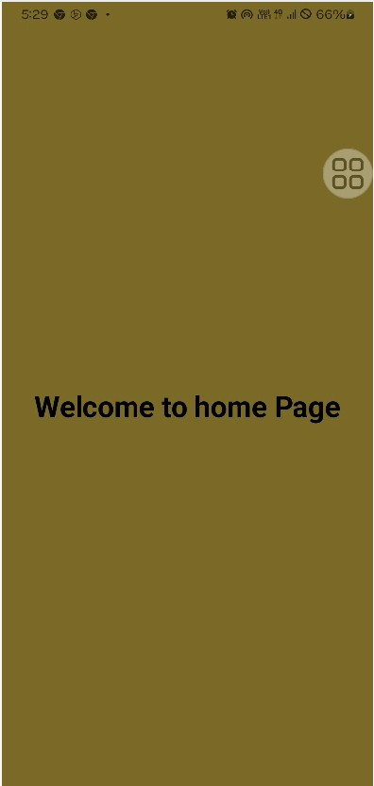

**Program 6:**

Create an UI with all views.

*<?*xml version="1.0" encoding="utf-8"*?>*

<LinearLayout xmlns:android=["http://schemas.android.com/](http://schemas.android.com/apk/res/android)a[pk/res/android"](http://schemas.android.com/apk/res/android) xmlns:app=["http://sc](http://schemas.android.com/apk/res-auto)h[emas.android.com/apk/res-auto"](http://schemas.android.com/apk/res-auto) xmlns:t[ools="ht](http://schemas.android.com/tools)tp:/[/sc](http://schemas.android.com/tools)he[mas.android.com/tools"](http://schemas.android.com/tools)

android:id="@+id/main" android:layout_width="match_parent" android:layout_height="match_parent" tools:context=".MainActivity" android:gravity="center" android:orientation="vertical" android:padding="30dp" android:background="@drawable/bg_outer">

<TextView android:layout_width="wrap_content" android:layout_height="wrap_content" android:text="User Information" android:textSize="30sp" android:textStyle="bold" android:textColor="#26389C"/><ImageView android:layout_width="wrap_content" android:layout_height="wrap_content" android:src="@drawable/account_img"/>

<ToggleButton android:layout_width="wrap_content" android:layout_height="wrap_content" android:textOn="Active" android:textOff="Inactive"/>

<View

android:layout_width="match_parent" android:layout_height="40dp"/>

<LinearLayout android:layout_width="match_parent" android:layout_height="wrap_content" android:paddingTop="30dp" android:paddingBottom="30dp" android:paddingLeft="5dp" android:paddingRight="5dp" android:orientation="vertical" android:background="@drawable/bg_inner">

<LinearLayout android:layout_width="match_parent" android:layout_height="wrap_content" android:orientation="horizontal" android:padding="5dp">

<TextView

android:layout_width="wrap_content"

android:layout_height="wrap_content"

android:text="Name"

android:textSize="20sp"

android:textStyle="bold"

android:textColor="#26389C"

android:padding="15dp"/>

<EditText

android:layout_width="match_parent"

android:layout_height="60dp"

android:id="@+id/name"

android:background="@drawable/bg"

android:padding="15dp"/>

</LinearLayout>

<LinearLayout

android:layout_width="match_parent" android:layout_height="wrap_content" android:orientation="horizontal" android:padding="5dp">

<TextView

android:layout_width="wrap_content”

android:layout_height="wrap_content"

android:text="E-mail"

android:textSize="20sp"

android:textStyle="bold"

android:textColor="#26389C"

android:padding="15dp"/>

<EditText

android:id="@+id/email" android:layout_width="match_parent" android:layout_height="60dp" android:ems="10" android:inputType="textEmailAddress" android:background="@drawable/bg" android:padding="15dp"/>

</LinearLayout>

<LinearLayout android:layout_width="match_parent" android:layout_height="wrap_content" android:orientation="horizontal" android:padding="5dp">

<TextView android:layout_width="wrap_content" android:layout_height="wrap_content" android:text="Sex" android:textSize="20sp" android:textStyle="bold" android:textColor="#26389C" android:padding="15dp" android:paddingEnd="40dp"/>

<RadioGroup android:layout_width="wrap_content" android:layout_height="wrap_content" android:background="@drawable/bg" android:orientation="horizontal" android:id="@+id/sex">

<RadioButton android:layout_width="wrap_content" android:layout_height="wrap_content" android:id="@+id/male" android:padding="15dp" android:text="Male" android:textColor="#26389C" android:textSize="20sp" android:textStyle="bold" />

<RadioButton android:layout_width="wrap_content" android:layout_height="wrap_content" android:id="@+id/female" android:padding="15dp"

android:text="Female" android:textColor="#26389C" android:textSize="20sp" android:textStyle="bold" />

</RadioGroup>

</LinearLayout>

<LinearLayout android:layout_width="match_parent" android:layout_height="wrap_content" android:orientation="horizontal" android:padding="5dp">

<TextView

android:layout_width="wrap_content" android:layout_height="wrap_content" android:text="Country" android:textSize="20sp" android:textStyle="bold" android:textColor="#26389C" android:padding="15dp" android:paddingEnd="5dp" />

<Spinner

android:layout_width="match_parent" android:layout_height="60dp" android:id="@+id/country" android:padding="15dp" android:background="@drawable/bg"/>

</LinearLayout>

</LinearLayout>

<View

android:layout_width="match_parent" android:layout_height="40dp"/>

<Button

android:layout_width="210dp" android:layout_height="wrap_content" android:id="@+id/submit" android:background="@drawable/bg" android:padding="15dp" android:text="Submit" android:textColor="#26389C" android:textSize="20sp" android:textStyle="bold" />

</LinearLayout>

package com.example.all_views;

import android.app.Dialog; import android.content.Context;

import android.content.DialogInterface; import android.os.Bundle;

import android.view.View; import android.view.ViewGroup;

import android.widget.ArrayAdapter; import android.widget.Button; import android.widget.EditText; import android.widget.RadioButton; import android.widget.RadioGroup; import android.widget.Spinner; import android.widget.Toast;

import androidx.activity.EdgeToEdge;

import androidx.appcompat.app.AlertDialog;

import androidx.appcompat.app.AppCompatActivity; import androidx.core.graphics.Insets;

import androidx.core.view.ViewCompat;

import androidx.core.view.WindowInsetsCompat;

public class MainActivity extends AppCompatActivity { Button sub;

@Override

protected void onCreate(Bundle savedInstanceState) { super.onCreate(savedInstanceState); EdgeToEdge.*enable*(this); setContentView(R.layout.*activity_main*);

Button sub=findViewById(R.id.*submit*);

sub.setOnClickListener(new View.OnClickListener() { @Override

public void onClick(View v) { showMessage(MainActivity.this,"User Information","Successfully

completed");

}

});

String[] item=new String[]{"India", "Pakisthan", "China", "America", "England"};

ArrayAdapter adapter = new ArrayAdapter<>(this, android.R.layout.*simple_spinner_item*, item);

adapter.setDropDownViewResource(android.R.layout.*simple_spinner_dropdown_i tem*);

Spinner spinner = findViewById(R.id.*country*); spinner.setAdapter(adapter);

}

public void showMessage(Context con,String t, String msg)

{

AlertDialog.Builder builder = new AlertDialog.Builder(con); builder.setTitle(t);

builder.setMessage(msg);

builder.setPositiveButton("OK", new DialogInterface.OnClickListener() { @Override

public void onClick(DialogInterface dialog, int which) { dialog.dismiss();

}

});

builder.show();

}

}

**Output**

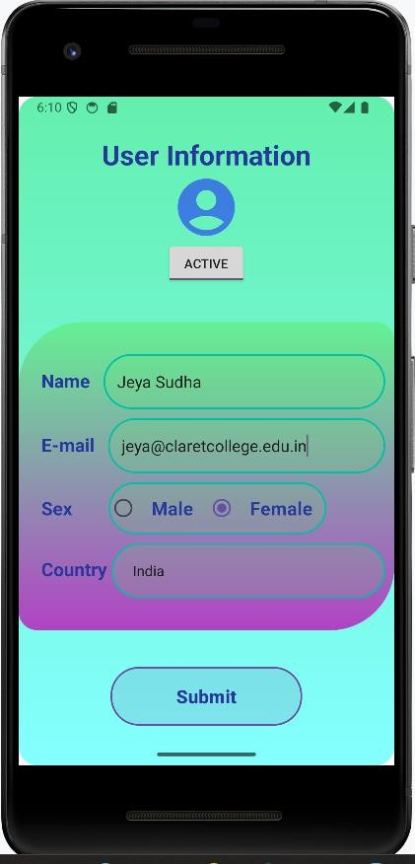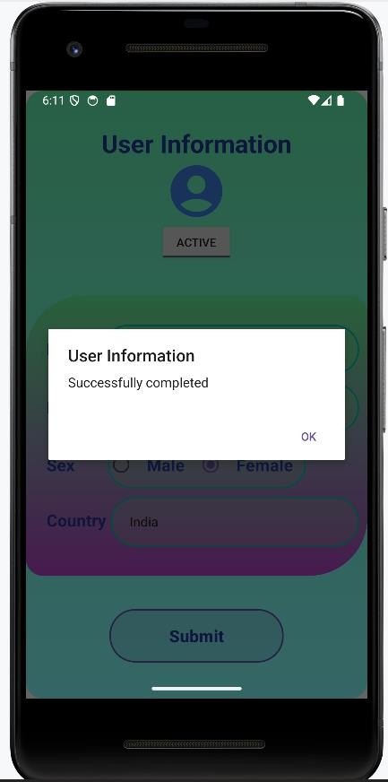

**Program 7:**

Create menu in Application

*<?*xml version="1.0" encoding="utf-8"*?>*

<menu xmlns:android="[http://schemas.android.com/apk/res/android"](http://schemas.android.com/apk/res/android)>

<item android:id="@+id/php" android:title="PHP"/>

<item android:id="@+id/java"

android:title="JAVA"/>

<item android:id="@+id/csharp" android:title="C#"/>

</menu>

package com.example.menuexample; import android.content.Intent;

import android.os.Bundle; import android.view.Menu;

import android.view.MenuInflater; import android.view.MenuItem; import android.widget.Toast;

import androidx.activity.EdgeToEdge; import androidx.annotation.NonNull;

import androidx.appcompat.app.AppCompatActivity; import androidx.core.graphics.Insets;

import androidx.core.view.ViewCompat;

import androidx.core.view.WindowInsetsCompat; public class MainActivity extends AppCompatActivity {

@Override

protected void onCreate(Bundle savedInstanceState) { super.onCreate(savedInstanceState); EdgeToEdge.*enable*(this);

setContentView(R.layout.*activity_main*);

}

@Override

public boolean onCreatePanelMenu(int featureId, @NonNull Menu menu) { MenuInflater inflater=getMenuInflater(); inflater.inflate(R.menu.*menus*,menu);

return true;

}

@Override

public boolean onOptionsItemSelected(@NonNull MenuItem item) { if(item.getItemId()==R.id.*php*) {

Toast.*makeText*(this, "Php Page", Toast.*LENGTH_SHORT*).show();

}

if(item.getItemId()==R.id.*java*) {

Toast.*makeText*(this, "Java Page", Toast.*LENGTH_SHORT*).show();

}

if(item.getItemId()==R.id.*csharp*) {

Toast.*makeText*(this, "C# Page", Toast.*LENGTH_SHORT*).show();

}

return super.onOptionsItemSelected(item);

}

}

*<?*xml version="1.0" encoding="utf-8"*?>*

<manifest xmlns:android=["http://schemas.android.com/](http://schemas.android.com/apk/res/android)a[pk/res/android"](http://schemas.android.com/apk/res/android) xmlns:tools=["http://schemas.android.com/tool](http://schemas.android.com/tools)s">

<uses-permission android:name="android.permission.INTERNET" />

<application android:allowBackup="true"

android:dataExtractionRules="@xml/data_extraction_rules" android:fullBackupContent="@xml/backup_rules" android:icon="@mipmap/ic_launcher" android:label="@string/app_name" android:roundIcon="@mipmap/ic_launcher_round" android:supportsRtl="true" android:theme="@style/Theme.AppCompat.Light" tools:targetApi="31">

<activity android:name=".MainActivity" android:exported="true">

<intent-filter>

<action android:name="android.intent.action.MAIN" />

<category android:name="android.intent.category.LAUNCHER" />

</intent-filter>

</activity>

</application>

</manifest>

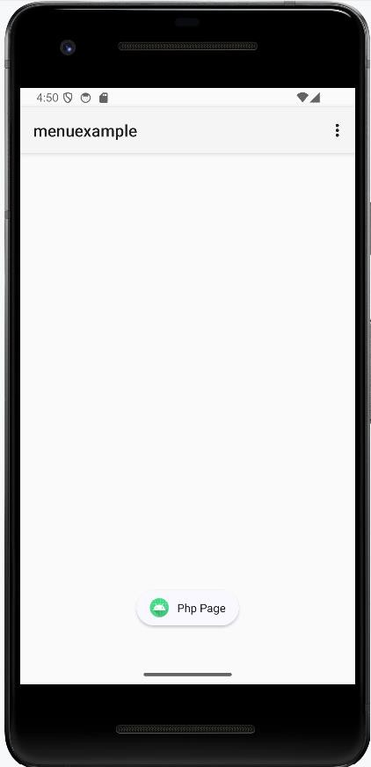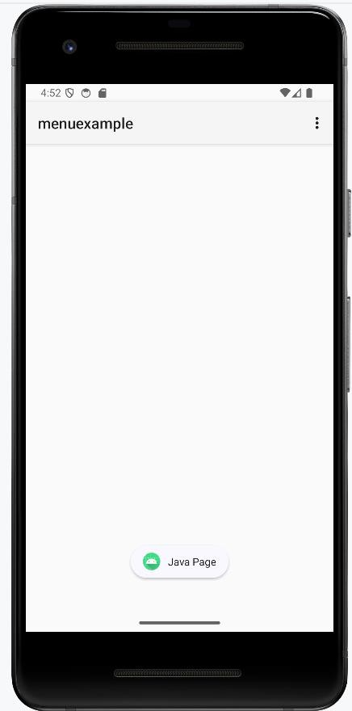 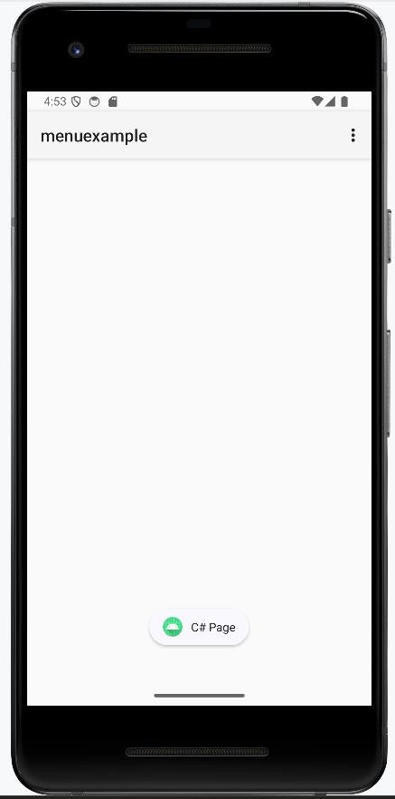 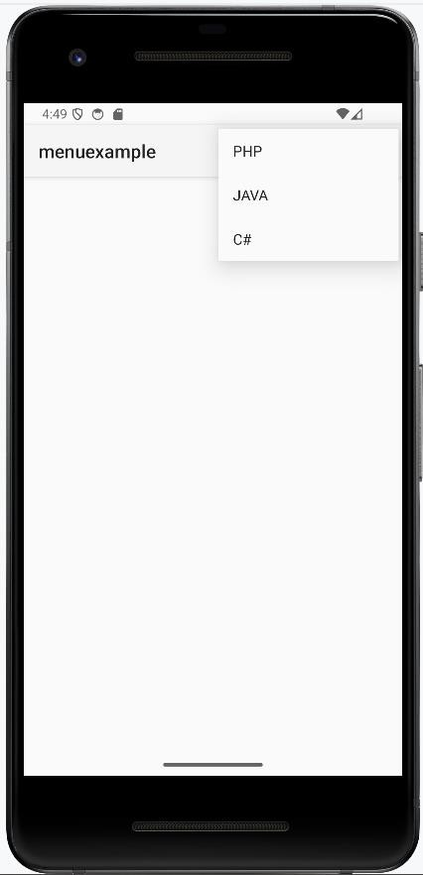

**Program 8:**

Read/ write the Local data

**activity_main.xml**

<?xml version="1.0" encoding="utf8"?>

<LinearLayout xmlns:android="[http://schemas.android.com/apk/res/android"](http://schemas.android.com/apk/res/android) xmlns:app="<http://schemas.android.com/apk/resauto>" xmlns:tools="<http://schemas.android.com/tools>" android:layout_width="match_parent"

android:layout_height="match_parent"

tools:context=".MainActivity"

android:orientation="vertical">

<TextView

android:layout_width="match_parent" android:layout_height="wrap_content" android:text="User Name">

</TextView>

<EditText android:id="@+id/etUserName"

android:layout_width="match_parent"

android:layout_height="wrap_content">

</EditText>

<TextView android:layout_width="match_parent" android:layout_height="wrap_content" android:text="Password">  
 </TextView>

<EditText android:id="@+id/etPassword" android:layout_width="match_parent" android:layout_height="wrap_content">

</EditText>

<Button

android:id="@+id/btnsave" android:layout_width="wrap_content" android:layout_height="wrap_content" android:text="Save" />

<Button android:id="@+id/btnnext"

android:layout_width="wrap_content" android:layout_height="wrap_content"

android:text="Next" />

</LinearLayout>

# MainActivity.java

package com.bca.localdata;

import androidx.appcompat.app.AppCompatActivity; import android.content.Context;

import android.content.Intent;

import android.content.SharedPreferences; import android.os.Bundle;

import android.view.View; import android.widget.Button; import android.widget.EditText; import android.widget.Toast;

public class MainActivity extends AppCompatActivity { Button btnsave,btnnext;

EditText etUserName,etPassword;

@Override

protected void onCreate(Bundle savedInstanceState) { super.onCreate(savedInstanceState); setContentView(R.layout.*activity_main*); btnsave=(Button) findViewById(R.id.*btnsave*); btnnext = (Button) findViewById(R.id.*btnnext*);

etUserName = (EditText)findViewById(R.id.*etUserName*); etPassword = (EditText)findViewById(R.id.*etPassword*);

btnsave.setOnClickListener(new View.OnClickListener() {

@Override

public void onClick(View view) {

// Writing data to SharedPreferences

SharedPreferences sharedPreferences = getSharedPreferences("MyPrefs", Context.*MODE_PRIVATE*);

SharedPreferences.Editor editor = sharedPreferences.edit(); editor.putString("username",

etUserName.getText().toString());

editor.putString("password",

etPassword.getText().toString());

editor.apply();

Toast.*makeText*(getApplicationContext(),"Saved successfully",Toast.*LENGTH_LONG*).show();

}

});

btnnext.setOnClickListener(new View.OnClickListener() {

@Override

public void onClick(View view) {

Intent intent = new Intent(getApplicationContext(),MainActivity2.class);

startActivity(intent);

}

});

}

}

# activity_main2.xml

<?xml version="1.0" encoding="utf8"?>

<LinearLayout xmlns:android="[http://schemas.android.com/apk/res/android"](http://schemas.android.com/apk/res/android) xmlns:app="<http://schemas.android.com/apk/resauto>" xmlns:tools="<http://schemas.android.com/tools>" android:layout_width="match_parent" android:layout_height="match_parent"

tools:context=".MainActivity2" android:orientation="vertical">

<Button android:id="@+id/btnFetch" android:layout_width="wrap_content" android:layout_height="wrap_content" android:text="Fetch" />

<TextView android:layout_width="match_parent" android:layout_height="wrap_content" android:text="User Name">

</TextView>

<EditText android:id="@+id/etUserName" android:layout_width="match_parent" android:layout_height="wrap_content">

</EditText>

<TextView android:layout_width="match_parent" android:layout_height="wrap_content" android:text="Password">  
</TextView>

<EditText android:id="@+id/etPassword" android:layout_width="match_parent" android:layout_height="wrap_content">

</EditText>

</LinearLayout>

# MainActivity2.java

package com.bca.localdata;

import androidx.appcompat.app.AppCompatActivity; import android.content.Context;

import android.content.SharedPreferences;

import android.os.Bundle;

import android.view.View;

import android.widget.Button;

import android.widget.EditText;

public class MainActivity2 extends AppCompatActivity {

Button btnFetch;

EditText etUserName,etPassword;

@Override

protected void onCreate(Bundle savedInstanceState)

{

super.onCreate(savedInstanceState); setContentView(R.layout.*activity_main2*);

btnFetch = (Button) findViewById(R.id.*btnFetch*); etUserName = (EditText)findViewById(R.id.*etUserName*); etPassword = (EditText)findViewById(R.id.*etPassword*); btnFetch.setOnClickListener(new View.OnClickListener()

{ @Override

public void onClick(View view)

{

// Reading data from SharedPreferences

SharedPreferences sharedPreferences=getSharedPreferences("MyPrefs",Context.*MODE_PRIVATE*);

String username = sharedPreferences.getString("username", "");

String password = sharedPreferences.getString("password", "");

etUserName.setText(username); etPassword.setText(password);

}

});

}

}

**Output**

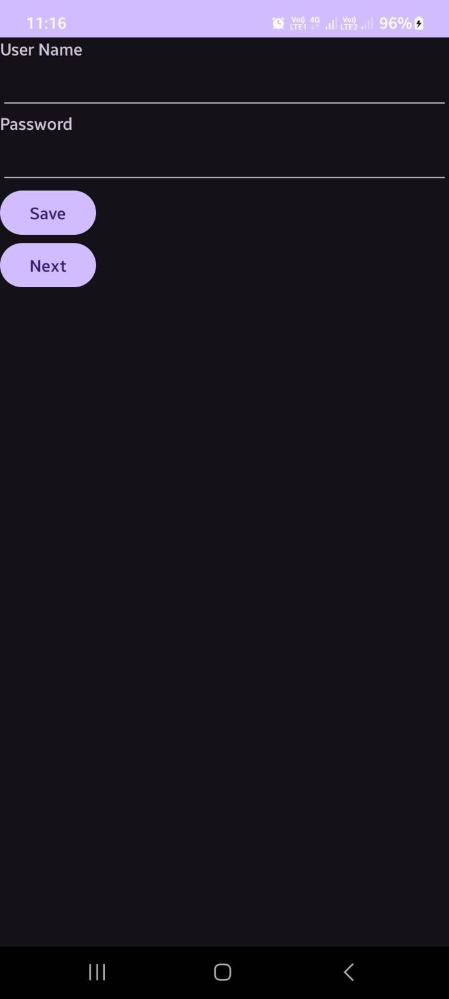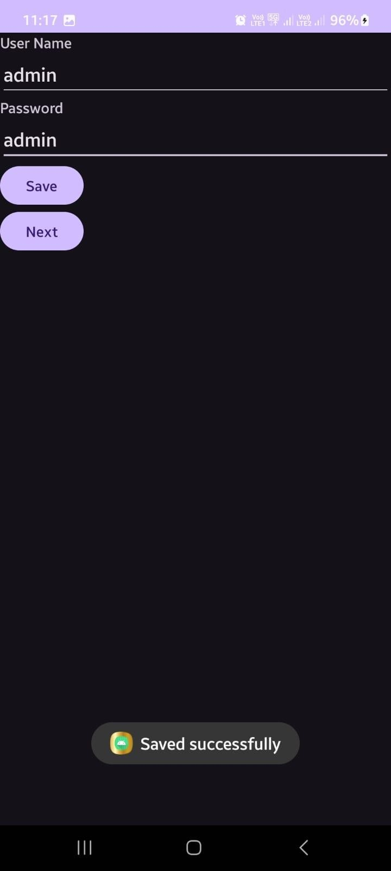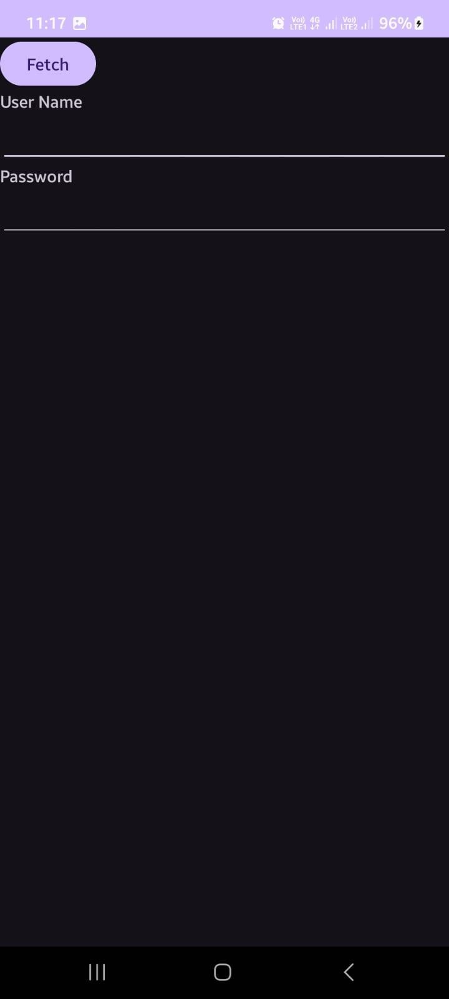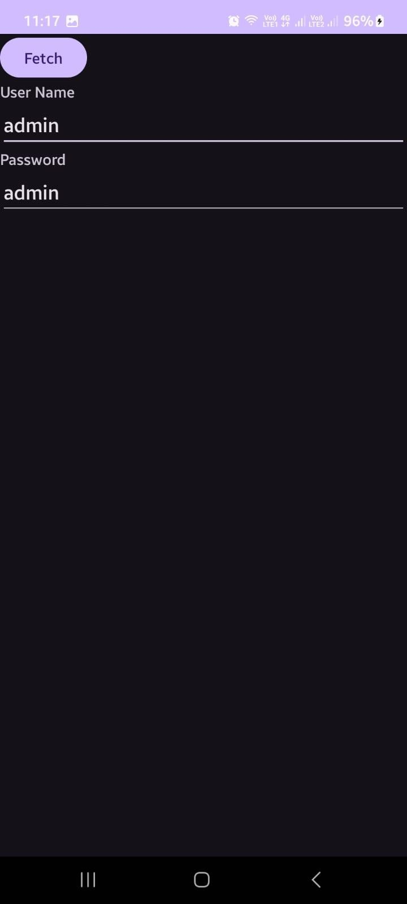

**Program 9:**

Create / Read / Write data with database (SQL Lite)

# activity_main.xml

*<?*xml version="1.0" encoding="utf-8"*?>*

<LinearLayout xmlns:android[="http://schemas.android.com/apk/res/android"](http://schemas.android.com/apk/res/android) xmlns:app[="http://schemas.android.com/apk/res](http://schemas.android.com/apk/res-auto)-[auto"](http://schemas.android.com/apk/res-auto) xmlns:tools[="http://schemas.android.com/tools"](http://schemas.android.com/tools) android:layout_width="match_parent" android:layout_height="match_parent" android:orientation="vertical"android:gravity="center" tools:context=".MainActivity">

<LinearLayout android:layout_width="wrap_content" android:layout_height="wrap_content"

android:orientation="vertical"

android:gravity="center">

<TextView

android:layout_width="wrap_content" android:layout_height="wrap_content" android:text="CourseRegistation" android:textColor="@color/colorAccent"  
 android:textSize="30dp"/>

</LinearLayout>

<LinearLayout

android:layout_width="wrap_content"

android:layout_height="wrap_content" android:orientation="horizontal"  
 android:gravity="center">

<TextView android:layout_width="wrap_content"

android:layout_height="wrap_content"

android:text="Name"/>

<EditText android:layout_width="wrap_content" android:layout_height="wrap_content" android:layout_weight="1"

android:ems="10"

android:id="@+id/name" android:textAlignment="center"/>

</LinearLayout>

<LinearLayout android:layout_width="wrap_content" android:layout_height="wrap_content"

android:orientation="horizontal"

android:gravity="center">

<TextView android:layout_width="wrap_content" android:layout_height="wrap_content" android:text="Course"/>

<EditText android:layout_width="wrap_content" android:layout_height="wrap_content" android:layout_weight="1"

android:ems="10"

android:id="@+id/course" android:textAlignment="center"/>

</LinearLayout>

<LinearLayout

android:layout_width="wrap_content"

android:layout_height="wrap_content"

android:orientation="horizontal"

android:gravity="center">

<TextView

android:layout_width="wrap_content"

android:layout_height="wrap_content"android:text="Fee"/>

<EditText

android:layout_width="wrap_content"

android:layout_height="wrap_content"

android:layout_weight="1"

android:ems="10"

android:id="@+id/fee"

android:textAlignment="center"/>

</LinearLayout>

<LinearLayout

android:layout_width="wrap_content"  
 android:layout_height="wrap_content"

android:orientation="horizontal"

android:gravity="center">

<Button  
 android:layout_width="wrap_content”  
 android:layout_height="wrap_content"

android:layout_weight="1"

android:id="@+id/bt1"

android:text="Ok"  
 android:background="@color/colorPrimary"/>

<Button   
 android:layout_width="wrap_content"  
 android:layout_height="wrap_content"

android:layout_weight="1"

android:id="@+id/bt2"

android:text="View"  
 android:background="@color/colorAccent"/>

</LinearLayout>

</LinearLayout>

**MainActivity.java** package com.bca.sqlite;

**import** androidx.appcompat.app.AppCompatActivity;

**import** android.content.Context;

**import** android.content.Intent;

**import** android.database.sqlite.SQLiteDatabase;

**import** android.database.sqlite.SQLiteStatement;

**import** android.os.Bundle;  
 **import** android.view.View;

**import** android.widget.Button;

**import a**ndroid.widget.EditText;

**import** android.widget.Toast;

**public class** MainActivity **extends** AppCompatActivity{

EditText **ed1**,**ed2**,**ed3**;  
 Button **b1**,**b2**;

@Override

**protected void** onCreate(Bundle savedInstanceState)

{**super**.onCreate(savedInstanceState); setContentView(R.layout.***activity_main***);

**ed1** = findViewById(R.id.***name***);

**ed2** = findViewById(R.id.***course***);

**ed3** = findViewById(R.id.***fee***);

**b1** = findViewById(R.id.***bt1***); **b2** = findViewById(R.id.***bt2***);

**b2**.setOnClickListener(**new** View.OnClickListener(){

@Override

**public void** onClick(View v)

{

Intent i = **new** Intent(getApplicationContext(),ViewActivity.**class**);  
startActivity(i);

}

});

**b1**.setOnClickListener(**new** View.OnClickListener() {

@Override

**public void** onClick(View v) { insert();

}

});

}

**public void** insert()

{

try

{

String name = **ed1**.getText().toString();  
 String course = **ed2**.getText().toString();  
 String fee = **ed3**.getText().toString();

SQLiteDatabase db = openOrCreateDatabase(**"SliteDb"**, Context.***MODE_PRIVATE***, **null**);

db.execSQL("CREATE TABLE IF NOT EXISTS records(id INTEGER PRIMARY KEY AUTOINCREMENT,name VARCHAR,course VARCHAR,fee VARCHAR)");

String sql = **"insert into records(name,course,fee)values('"** +name + **"','"** + course + **"','"** + fee + **"')"**;

SQLiteStatement statement = db.compileStatement(sql); statement.execute();

Toast.*makeText*(**this**,**"Record addded"**,Toast.***LENGTH_LONG***).show();

**ed1**.setText(**""**);  
**ed2**.setText(**""**);

**ed3**.setText(**""**);  
 **ed1**.requestFocus();

}

**catch** (Exception ex)

{

Toast.*makeText*(**this**,**"Record Fail"**,Toast.***LENGTH_LONG***).show();

}

}

}

/* Add Student.class file (Right click on package name */

**Student.class**

**package** com.bca.sqlite; **public class** Student { String **id**;

String **name**; String **course**;  
String **fee**; String **titles**;

}

# activity_view.xml

*<?*xml version="1.0" encoding="utf-8"*?>*

<LinearLayout xmlns:android[="http://schemas.android.com/apk/res/android"](http://schemas.android.com/apk/res/android) xmlns:app="[http://schemas.android.com/apk/res-auto"](http://schemas.android.com/apk/res-auto) xmlns:tools[="http://schemas.android.com/tools"](http://schemas.android.com/tools) android:layout_width="match_parent" android:layout_height="match_parent"

tools:context=".ViewActivity" android:orientation="vertical">

<ListView android:layout_width="match_parent"

android:layout_height="match_parent"

android:id="@+id/lst1"/>

</LinearLayout>

**ViewActivity.java package** com.bca.sqlite;

**import** androidx.appcompat.app.AppCompatActivity;

**import** ndroid.content.Context;  
 **import** android.content.Intent;

**import** ndroid.database.Cursor;

**import** android.database.sqlite.SQLiteDatabase;

**import** android.os.Bundle;

**import** android.view.View;

**import** ndroid.widget.AdapterView;  
**import** ndroid.widget.ArrayAdapter; **import** android.widget.ListView;  
**import** java.util.ArrayList;

**public class** ViewActivity **extends** AppCompatActivity { ListView **lst1**;

ArrayList<String> **titles** = **new** ArrayList<String>();

ArrayAdapter **arrayAdapter**;

@Override

**protected void** onCreate(Bundle savedInstanceState) { **super**.onCreate(savedInstanceState); setContentView(R.layout.***activity_view***);

SQLiteDatabase db = openOrCreateDatabase(**"SliteDb"**,Context.***MODE_PRIVATE***,**null**);

**lst1** = findViewById(R.id.***lst1***);

**final** Cursor c = db.rawQuery(**"select * from records"**,**null**); **int** id = c.getColumnIndex(**"id"**);

**int** name = c.getColumnIndex(**"name"**); **int** course = c.getColumnIndex(**"course"**); **int** fee = c.getColumnIndex(**"fee"**); **titles**.clear();

**arrayAdapter** = **new** ArrayAdapter(**this**, androidx.appcompat.R.layout.*support_simple_spinner_dropdown_item*,**titles**);

**lst1**.setAdapter(**arrayAdapter**);

**final** ArrayList<Student> stud = **new** ArrayList<Student>();

**if**(c.moveToFirst())

{

**do**

{

Student stu = **new** Student();  
stu.**id** = c.getString(id); stu.**name** = c.getString(name); stu.**course** = c.getString(course)

;stu.**fee** = c.getString(fee); stud.add(stu);

**titles**.add(c.getString(id) + **" \t "** + c.getString(name) + **"**

**\t "** + c.getString(course) + **" \t "** + c.getString(fee) );

} **while**(c.moveToNext()); **arrayAdapter**.notifyDataSetChanged(); **lst1**.invalidateViews();

}

**lst1**.setOnItemClickListener(**new** AdapterView.OnItemClickListener()

{@Override

**public void** onItemClick(AdapterView parent, View view, **int** position, **long** id) { String aa = **titles**.get(position).toString();

Student stu = stud.get(position); Intent i = **new**

Intent(getApplicationContext(),EditActivity.**class**);

i.putExtra(**"id"**,stu.**id**);

i.putExtra(**"name"**,stu.**name**); i.putExtra(**"course"**,stu.**course**);

i.putExtra(**"fee"**,stu.**fee**);

startActivity(i);

}

});

}

}

# activity_edit.xml

*<?*xml version="1.0" encoding="utf-8"*?>*

<LinearLayout xmlns:android="[http://schemas.android.com/apk/res/android"](http://schemas.android.com/apk/res/android) xmlns:app[="http://schemas.android.com/apk/res](http://schemas.android.com/apk/res-auto)-[auto"](http://schemas.android.com/apk/res-auto) xmlns:tools[="http://schemas.android.com/tools"](http://schemas.android.com/tools) android:layout_width="match_parent"   
android:layout_height="match_parent"   
tools:context=".EditActivity"   
android:orientation="vertical">

<LinearLayout android:layout_width="wrap_content" android:layout_height="wrap_content" android:orientation="vertical" android:gravity="center">

<TextView android:layout_width="wrap_content" android:layout_height="wrap_content" android:text="Course Registation" android:textColor="@color/colorAccent" android:textSize="30dp"/>  
</LinearLayout>

<LinearLayout android:layout_width="wrap_content" android:layout_height="wrap_content"  
android:orientation="horizontal"  
android:gravity="center">

<TextView android:layout_width="wrap_content"

android:layout_height="wrap_content"

android:text="ID"/>

<EditText

android:layout_width=”wrap_content”

android:layout_height=”wrap_content”

android:layout_weight=”1”

android:ems=”10”

android:”@+id/id”

android:textAlignment=”center”/>

</LinearLayout>

<LinearLayout android:layout_width="wrap_content" android:layout_height="wrap_content"  
android:orientation="horizontal"  
android:gravity="center">

<TextView android:layout_width="wrap_content"

android:layout_height="wrap_content"

android:text="Name"/>

<EditText

android:layout_width=”wrap_content”

android:layout_height=”wrap_content”

android:layout_weight=”1”

android:ems=”10”

android:”@+id/name”

android:textAlignment=”center”/>

</LinearLayout>

<LinearLayout android:layout_width="wrap_content" android:layout_height="wrap_content"

android:orientation="horizontal"

android:gravity="center">

<TextView android:layout_width="wrap_content" android:layout_height="wrap_content" android:text="Course"/>

<EditText android:layout_width="wrap_content" android:layout_height="wrap_content" android:layout_weight="1"

android:ems="10" android:id="@+id/course" android:textAlignment="center"/>

</LinearLayout>

<LinearLayout android:layout_width="wrap_content" android:layout_height="wrap_content" android:orientation="horizontal" android:gravity="center">

<TextView android:layout_width="wrap_content" android:layout_height="wrap_content" android:text="Fee"/>

<EditText android:layout_width="wrap_content" android:layout_height="wrap_content" android:layout_weight="1" android:ems="10" android:id="@+id/fee" android:textAlignment="center"/>

</LinearLayout>

LinearLayout android:layout_width="wrap_content" android:layout_height="wrap_content"

android:orientation="horizontal" android:gravity="center">

<Button <android:layout_width="wrap_content" android:layout_height="wrap_content"

android:layout_weight="1"

android:id="@+id/bt1"

android:text="Edit"

android:background="@color/colorPrimary"/>

<Button android:layout_width="wrap_content" android:layout_height="wrap_content"

android:layout_weight="1"

android:id="@+id/bt2"

android:text="Delete" android:background="@color/colorAccent"/>

<Button android:layout_width="wrap_content" android:layout_height="wrap_content"

android:layout_weight="1"

android:id="@+id/bt3"

android:text="Back" android:background="@color/colorPrimaryDark"/>

</LinearLayout>

</LinearLayout>

**EditActivity.java**

**package** com.bca.sqlite;

**import** androidx.appcompat.app.AppCompatActivity;

**import** android.content.Context;

**import** android.content.Intent;

**import** android.database.sqlite.SQLiteDatabase;

**import** android.database.sqlite.SQLiteStatement;

**import** android.os.Bundle;

**import** android.view.View;

**import** android.widget.Button;

**import** android.widget.EditText;

**import** android.widget.Toast;

**public class** EditActivity **extends** AppCompatActivity

{

EditText **ed1**,**ed2**,**ed3**,**ed4**;

Button **b1**,**b2**,**b3**; @Override

**protected void** onCreate(Bundle savedInstanceState)

{

**super**.onCreate(savedInstanceState); setContentView(R.layout.***activity_edit***);

**ed1** = findViewById(R.id.***name***);

**ed2** = findViewById(R.id.***course***); **ed3** = findViewById(R.id.***fee***); **ed4** = findViewById(R.id.***id***);

**b1** = findViewById(R.id.***bt1***);

**b2** = findViewById(R.id.***bt2***);

**b3** = findViewById(R.id.***bt3***);

Intent i = getIntent();

String t1 = i.getStringExtra(**"id"**).toString(); String t2 = i.getStringExtra(**"name"**).toString(); String t3 = i.getStringExtra(**"course"**).toString(); String t4 = i.getStringExtra(**"fee"**).toString(); **ed4**.setText(t1);

**ed1**.setText(t2); **ed2**.setText(t3); **ed3**.setText(t4);

**b2**.setOnClickListener(**new** View.OnClickListener()

{@Override

**public void** onClick(View v) {

try

{

String id = **ed4**.getText().toString();SQLiteDatabase db = openOrCreateDatabase(**"SliteDb"**,Context.***MODE_PRIVATE***,**null**);

String sql = **"delete from records where id = "** + id + **""**; SQLiteStatement statement = db.compileStatement(sql);

statement.execute();  
Toast.*makeText*(EditActivity.**this**,**"RecordDeleted"**,Toast.***LENGTH_LONG***).show(); **ed1**.setText(**""**);

**ed2**.setText(**""**);

**ed3**.setText(**""**);  
**ed1**.requestFocus();

}

**catch** (Exception ex)

{

Toast.*makeText*(EditActivity.**this**,**"Record Fail"**,Toast.***LENGTH_LONG***).show();

}

}

});

**b3**.setOnClickListener(**new** View.OnClickListener() {@Override

**public void** onClick(View v) {

Intent i = **new** Intent(getApplicationContext(),ViewActivity.**class**); startActivity(i);

}

});

**b1**.setOnClickListener(**new** View.OnClickListener() {@Override

**public void** onClick(View v) { try {

String name = **ed1**.getText().toString(); String course = **ed2**.getText().toString(); String fee = **ed3**.getText().toString(); String id = **ed4**.getText().toString();

SQLiteDatabase db = openOrCreateDatabase(**"SliteDb"**,Context.***MODE_PRIVATE***, **null**);

String sql = **"update records set name = '"** + name + **"',course='"** +course +

**"',fee='"** + fee + **"' where id= "** + id + **""**; SQLiteStatement statement = db.compileStatement(sql); statement.execute();

Toast.*makeText*(EditActivity.**this**, **"Record Updated"**,

Toast.***LENGTH_LONG***).show();

**ed1**.setText(**""**);

**ed2**.setText(**""**);

**ed3**.setText(**""**); **ed1**.requestFocus();

} **catch** (Exception ex) {

Toast.*makeText*(EditActivity.**this**, **"Record Fail"**,

Toast.***LENGTH_LONG***).show();

}

}

});

} }

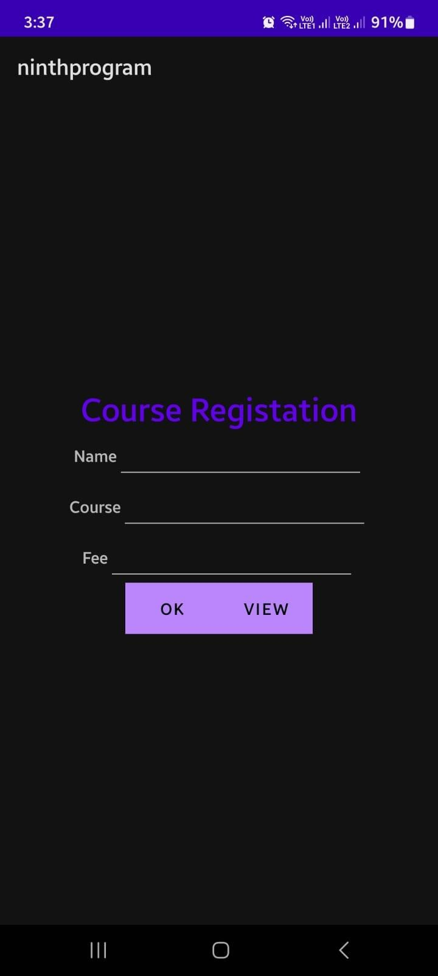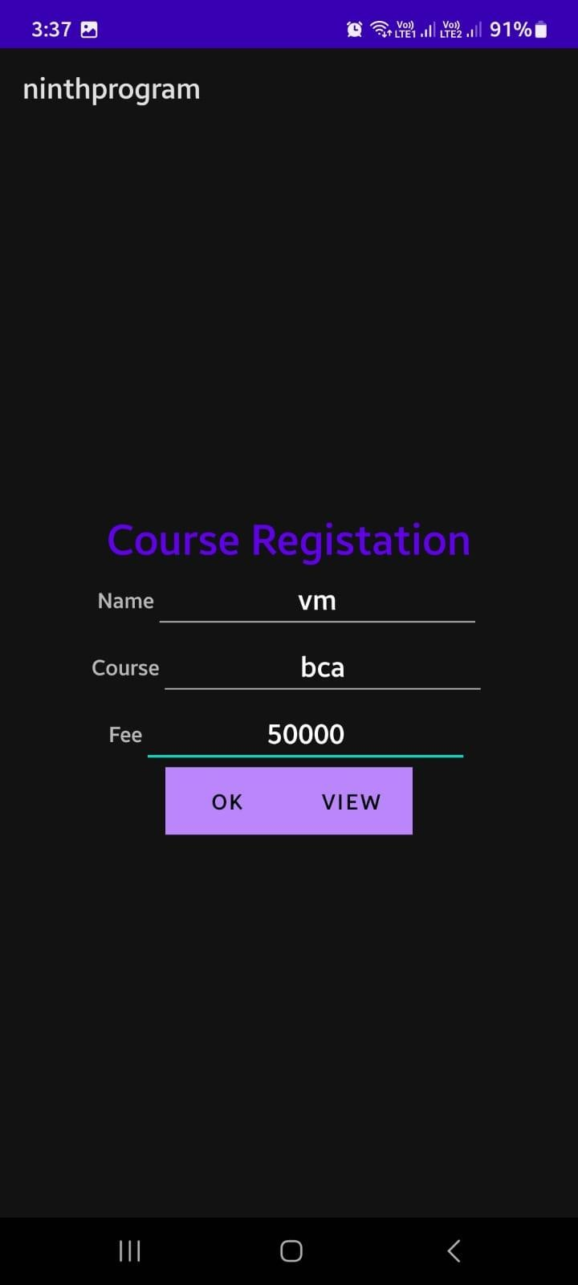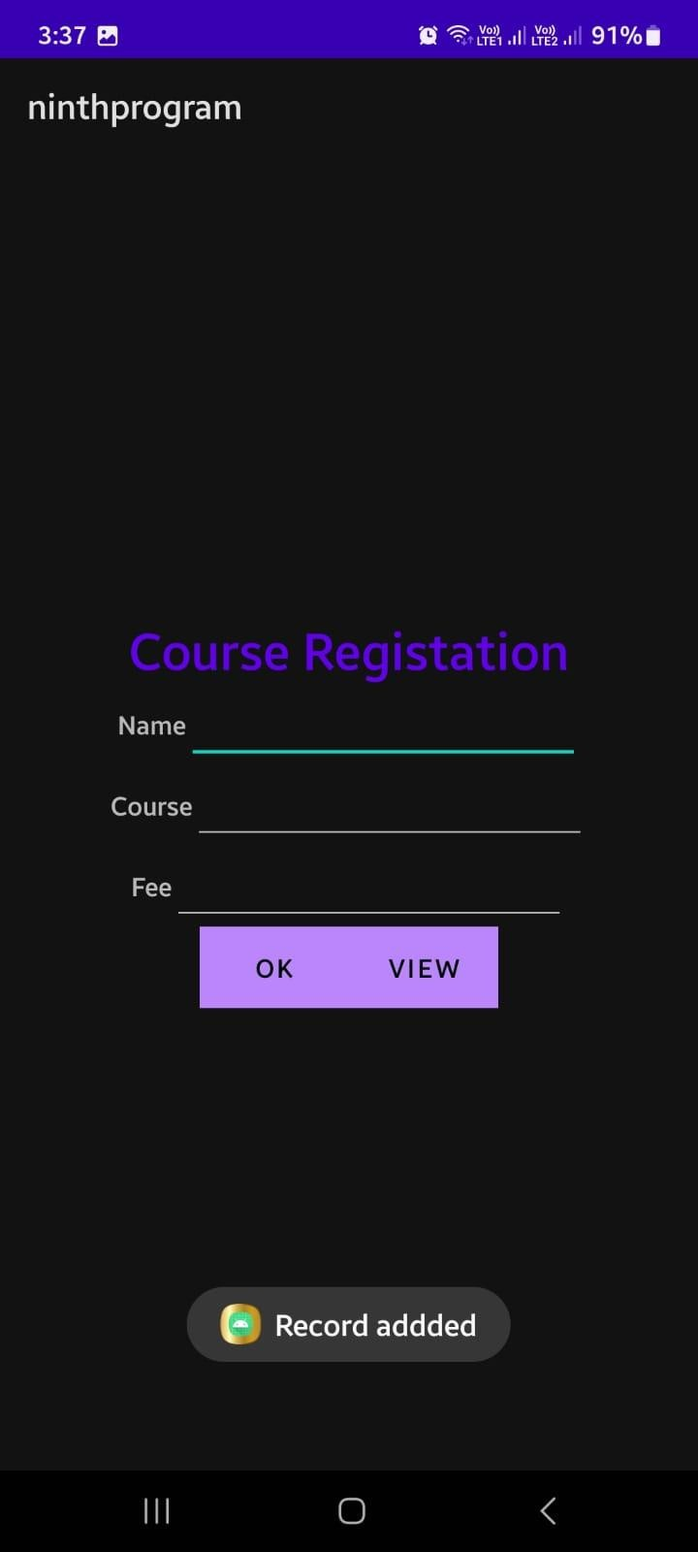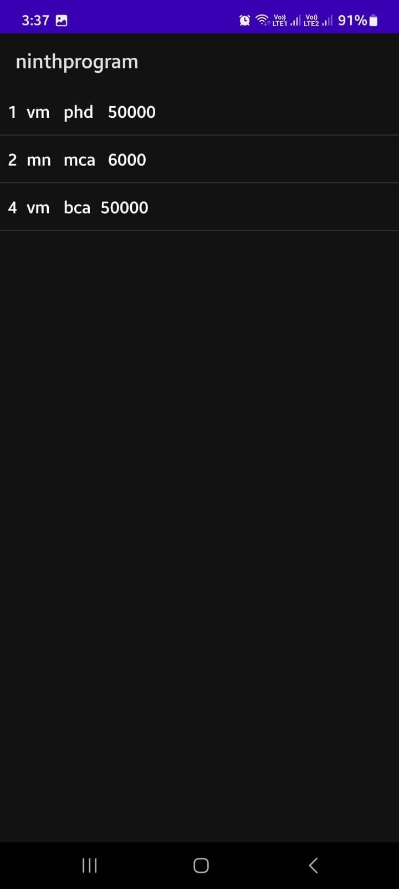

**Program 10:**

Create an application to send SMS and receive SMS

# activity_main.xml

<?xml version="1.0" encoding="utf-8"?>

<RelativeLayout xmlns:android="[http://schemas.android.com/apk/res/android"](http://schemas.android.com/apk/res/android) xmlns:tools="<http://schemas.android.com/tools>" android:layout_width="match_parent" android:layout_height="match_parent" android:background="@color/white"   
tools:context=".MainActivity">

<EditText  
 android:id="@+id/editTextPhoneNumber" android:layout_width="match_parent" android:layout_height="wrap_content"  
 android:hint="Enter phone number"  
 android:layout_margin="16dp"/>

<EditText android:id="@+id/editTextMessage" android:layout_width="match_parent" android:layout_height="wrap_content" android:hint="Enter message"

android:layout_below="@id/editTextPhoneNumber" android:layout_margin="16dp"/>

<Button

android:id="@+id/buttonSend" android:layout_width="wrap_content" android:layout_height="wrap_content" android:text="Send" android:layout_below="@id/editTextMessage" android:layout_alignParentEnd="true" android:layout_marginEnd="16dp"

android:onClick="sendMessage"

tools:ignore="UsingOnClickInXml" />

<TextView

android:id="@+id/textViewReceivedMessages"

android:layout_width="match_parent"

android:layout_height="wrap_content"

android:layout_below="@id/buttonSend"

android:layout_marginStart="16dp"

android:layout_marginTop="16dp"

android:layout_marginEnd="16dp"

android:layout_marginBottom="16dp"

android:textColor="@color/black" />

</RelativeLayout>

# MainActivity.java

package com.bca.sms;

import androidx.appcompat.app.AppCompatActivity;  
import androidx.core.app.ActivityCompat;

import androidx.core.content.ContextCompat; import android.content.BroadcastReceiver; import android.content.Context;

import android.content.Intent; import android.content.IntentFilter;

import android.content.pm.PackageManager; import android.os.Bundle;

import android.telephony.SmsManager; import android.telephony.SmsMessage; import android.view.View;

import android.widget.EditText; import android.widget.TextView; import android.widget.Toast; import android.Manifest;

import androidx.appcompat.app.AppCompatActivity;

public class MainActivity extends AppCompatActivity  
{

private static final int *SMS_PERMISSION_CODE* = 101; private EditText editTextPhoneNumber;

private EditText editTextMessage;

private TextView textViewReceivedMessages;

@Override

protected void onCreate(Bundle savedInstanceState)

{

super.onCreate(savedInstanceState); setContentView(R.layout.*activity_main*);

editTextPhoneNumber = findViewById(R.id.*editTextPhoneNumber*); editTextMessage = findViewById(R.id.*editTextMessage*); textViewReceivedMessages = findViewById(R.id.*textViewReceivedMessages*);

// Request SMS permissions if not granted

if (!checkSMSPermission())

{

requestSMSPermission();

}

// Register SMS receiver

IntentFilter intentFilter = new IntentFilter(); intentFilter.addAction("android.provider.Telephony.SMS_RECEIVED"); registerReceiver(smsReceiver, intentFilter);

}

@Override

protected void onDestroy()

{

super.onDestroy(); unregisterReceiver(smsReceiver);

}

// Button click listener for sending SMS

public void sendMessage(View view) { String phoneNumber = editTextPhoneNumber.getText().toString().trim();

String message = editTextMessage.getText().toString(); if (phoneNumber.isEmpty())

{

{

Toast.*makeText*(this, "Please enter a valid phone number", Toast.*LENGTH_SHORT*).show();

return;

}

try {

SmsManager smsManager = SmsManager.*getDefault*(); smsManager.sendTextMessage(phoneNumber, null, message, null, null); Toast.*makeText*(this, "Message sent", Toast.*LENGTH_SHORT*).show();

}

catch (IllegalArgumentException e)

{

Toast.*makeText*(this, "Invalid phone number format", Toast.*LENGTH_SHORT*).show();

} catch (Exception e) {

Toast.*makeText*(this, "Failed to send message", Toast.*LENGTH_SHORT*).show(); e.printStackTrace();

}

}

// Check if SMS permission is granted private boolean checkSMSPermission() {

return ContextCompat.*checkSelfPermission*(this, Manifest.permission.*SEND_SMS*) == PackageManager.*PERMISSION_GRANTED*;

}

// Request SMS permission

private void requestSMSPermission() { ActivityCompat.*requestPermissions*(this, new String[]{Manifest.permission.*SEND_SMS*}, *SMS_PERMISSION_CODE*);

}

// SMS receiver

private final BroadcastReceiver smsReceiver = new BroadcastReceiver()

{ @Override

public void onReceive(Context context, Intent intent) { Bundle bundle = intent.getExtras(); if (bundle != null)  
{  
Object[] pdus = (Object[]) bundle.get("pdus");  
 if (pdus != null) {

for (Object pdu : pdus)

{

SmsMessage smsMessage = SmsMessage.*createFromPdu*((byte[]) pdu); String senderPhoneNumber = smsMessage.getDisplayOriginatingAddress();

String messageBody = smsMessage.getMessageBody(); textViewReceivedMessages.append("From: " + senderPhoneNumber + "\n"); textViewReceivedMessages.append("Message: " +

messageBody + "\n\n");

}

}

}

}

};

}

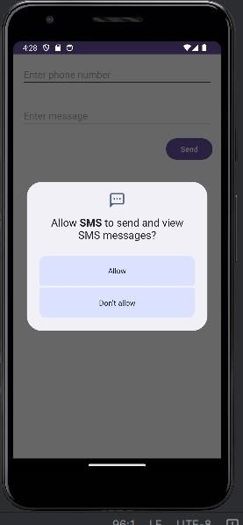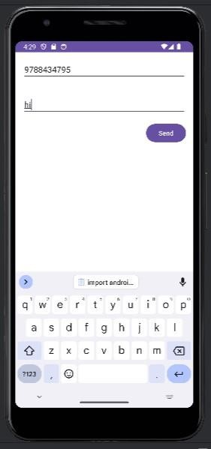

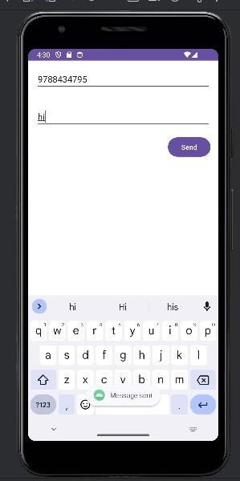

**Program 11:**

Create an application to send an Email.

# activity_main.xml

<?xml version="1.0" encoding="utf8"?>

<RelativeLayout xmlns:android="[http://schemas.android.com/apk/res/android"](http://schemas.android.com/apk/res/android) xmlns:tools="<http://schemas.android.com/tools>" android:layout_width="match_parent" android:layout_height="match_parent"

tools:context=".MainActivity">

<EditText android:id="@+id/editTextTo" android:layout_width="match_parent" android:layout_height="wrap_content" android:hint="To"/>

<EditText android:id="@+id/editTextSubject" android:layout_width="match_parent" android:layout_height="wrap_content" android:layout_below="@id/editTextTo" android:hint="Subject"/>

<EditText android:id="@+id/editTextMessage" android:layout_width="match_parent" android:layout_height="wrap_content"

android:layout_below="@id/editTextSubject" android:hint="Message"/>

<Button

android:id="@+id/buttonSend" android:layout_width="wrap_content" android:layout_height="wrap_content" android:layout_below="@id/editTextMessage"  
android:text="Send"/>

</RelativeLayout>

**Mainactivity.java**

package com.bca.email;  
import androidx.appcompat.app.AppCompatActivity;

import android.annotaion.SupperessLint;

import android.content.Intent; import android.os.Bundle;   
 import android.view.View; import android.widget.Button; import android.widget.EditText;

public class MainActivity extends AppCompatActivity { EditText editTextTo, editTextSubject, editTextMessage; Button buttonSend;

@Override

protected void onCreate(Bundle savedInstanceState)

{

super.onCreate(savedInstanceState); setContentView(R.layout.*activity_main*); editTextTo = findViewById(R.id.*editTextTo*);

editTextSubject = findViewById(R.id.*editTextSubject*); editTextMessage = findViewById(R.id.*editTextMessage*); buttonSend = findViewById(R.id.*buttonSend*); buttonSend.setOnClickListener(new View.OnClickListener()

{

@Override

public void onClick(View v)

{

sendEmail();

}

});

}

@SuppressLint("QueryPermissionsNeeded") private void sendEmail() {

String to = editTextTo.getText().toString().trim();

String subject = editTextSubject.getText().toString().trim(); String message = editTextMessage.getText().toString().trim(); Intent intent = new Intent(Intent.*ACTION_SEND*); intent.setType("text/plain"); intent.putExtra(Intent.*EXTRA_EMAIL*, new String[]{to}); intent.putExtra(Intent.*EXTRA_SUBJECT*, subject); intent.putExtra(Intent.*EXTRA_TEXT*, message);

if (intent.resolveActivity(getPackageManager()) != null)

{

startActivity(Intent.*createChooser*(intent, "Choose an email client"));

}

}

}

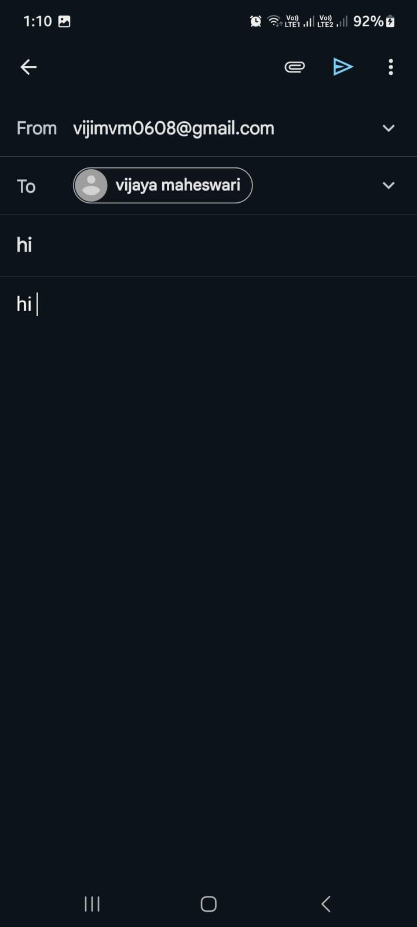

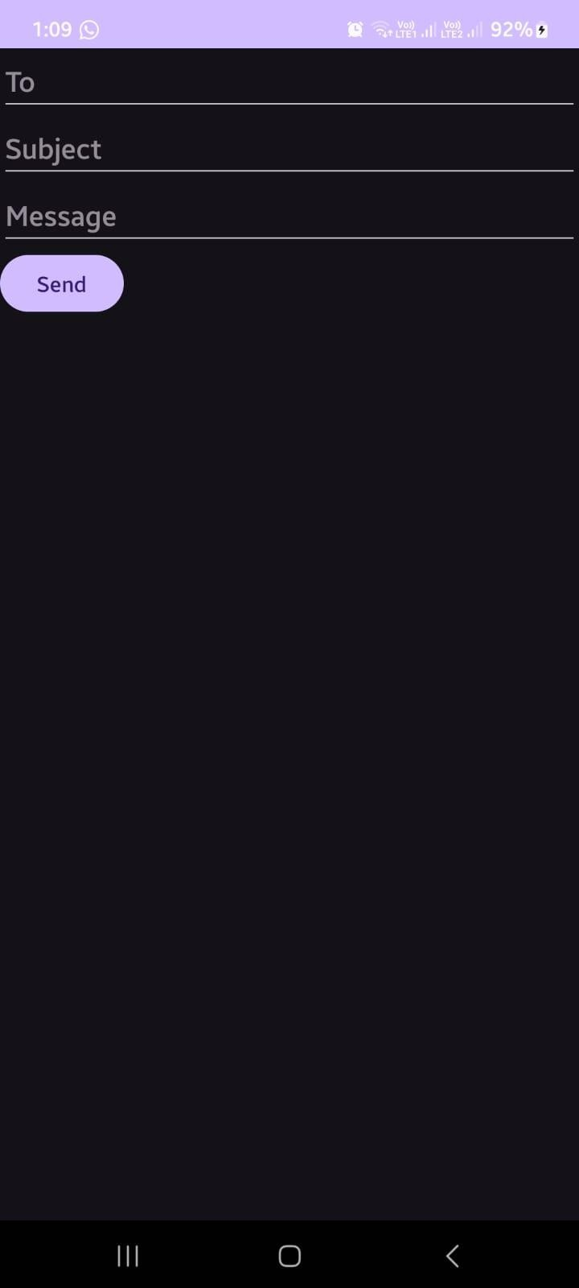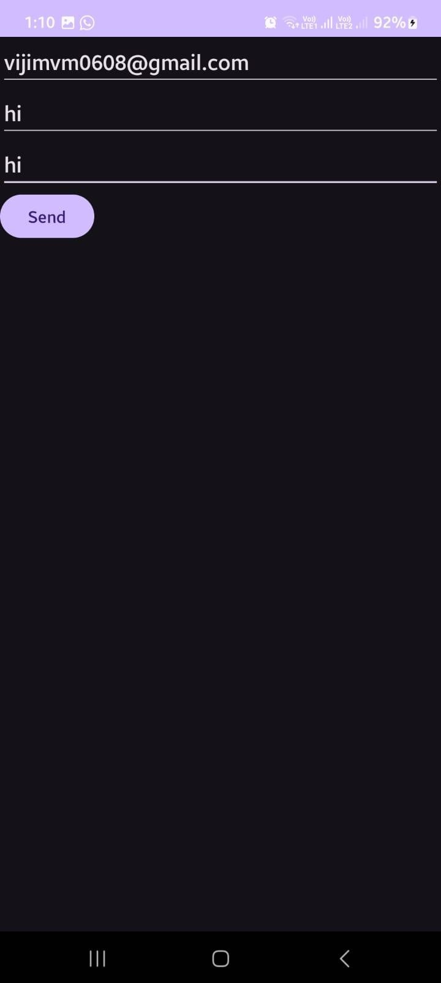

**Program 12:**

Display Map based on the Current/given location.

# MainActivity.java

import android.os.Bundle; import android.widget.Toast;

import androidx.annotation.NonNull;

import androidx.appcompat.app.AppCompatActivity;

import com.google.android.gms.maps.CameraUpdateFactory; import com.google.android.gms.maps.GoogleMap;

import com.google.android.gms.maps.OnMapReadyCallback; import com.google.android.gms.maps.SupportMapFragment; import com.google.android.gms.maps.model.LatLng;

import com.google.android.gms.maps.model.MarkerOptions;

public class MainActivity extends AppCompatActivity implements OnMapReadyCallback { private GoogleMap mMap;

private double latitude = 0.0; private double longitude = 0.0; @Override

protected void onCreate(Bundle savedInstanceState) { super.onCreate(savedInstanceState); setContentView(R.layout.activity_main);

// Obtain the SupportMapFragment and get notified when the map is ready to be used.

SupportMapFragment mapFragment = (SupportMapFragment) getSupportFragmentManager()

.findFragmentById(R.id.map); if (mapFragment != null) {

mapFragment.getMapAsync(this);

} else {

Toast.makeText(this, "Map Fragment Not Found", Toast.LENGTH_SHORT).show();

}

}

@Override

public void onMapReady(@NonNull GoogleMap googleMap) { mMap = googleMap;

// Add a marker at current or given location and move the camera LatLng location = new LatLng(latitude, longitude);

mMap.addMarker(new MarkerOptions().position(location).title("Marker")); mMap.moveCamera(CameraUpdateFactory.newLatLngZoom(location, 15));

}

}

# activity_main.xml

<?xml version="1.0" encoding="utf8"?>

<RelativeLayout xmlns:android="[http://schemas.android.com/apk/res/android"](http://schemas.android.com/apk/res/android) xmlns:tools="<http://schemas.android.com/tools>" android:layout_width="match_parent" android:layout_height="match_parent"  
 tools:context=".MainActivity">

<fragment  
android:id="@+id/map"

android:name="com.google.android.gms.maps.SupportMapFragment" android:layout_width="match_parent" android:layout_height="match_parent" android:layout_alignParentTop="true" android:layout_alignParentBottom="true"  
android:layout_alignParentStart="true" android:layout_alignParentEnd="true" />

</RelativeLayout>

# AndroidManifest.xml

<?xml version="1.0" encoding="utf8"?>

<manifest xmlns:android="[http://schemas.android.com/apk/res/android"](http://schemas.android.com/apk/res/android) package="com.yourpackage.yourappname">

<usespermission android:name="android.permission.ACCESS_FINE_LOCATION" />

<usespermission android:name="android.permission.ACCESS_COARSE_LOCATION" />

<usespermission android:name="android.permission.INTERNET" />

<application android:allowBackup="true" android:icon="@mipmap/ic_launcher" android:label="@string/app_name"

android:roundIcon="@mipmap/ic_launcher_round" android:supportsRtl="true" android:theme="@style/AppTheme">

<! Google Maps API Key >

<metadata android:name="com.google.android.geo.API_KEY" android:value="YOUR_API_KEY_HERE" />

<activity android:name=".MainActivity">

<intentfilter>

<action android:name="android.intent.action.MAIN" />

<category android:name="android.intent.category.LAUNCHER" />

</intentfilter>

</activity>

</application>

</manifest>

**Program 13:**

Create a sample application with login module (check user name and password) On successful login change Textview “Login Successful”. On login fail alert using Toast “login fail”

# activity_main.xml

<?xml version="1.0" encoding="utf-8"?>

<LinearLayout  
 xmlns:android="<http://schemas.android.com/apk/res/android>"

xmlns:app="<http://schemas.android.com/apk/res-auto>" xmlns:tools="<http://schemas.android.com/tools>"

android:layout_width="match_parent" android:layout_height="match_parent" tools:context=".MainActivity" android:orientation="vertical" android:padding="16dp">

<TextView

android:id="@+id/tvTitle" android:layout_width="wrap_content" android:layout_height="wrap_content" android:textSize="24sp" android:text="Login Form" android:layout_gravity="center"/>

<TextView

android:id="@+id/tvUserName" android:layout_width="wrap_content" android:layout_height="wrap_content" android:textSize="20sp"

android:text="User Name" />

<EditText   
 android:id="@+id/etUsername" android:layout_width="match_parent" android:layout_height="wrap_content" android:hint="Username" android:inputType="text" android:padding="8dp" android:layout_marginTop="16dp"

android:layout_marginBottom="30dp"/>

<TextView   
android:id="@+id/tvPassword" android:layout_width="wrap_content" android:layout_height="wrap_content" android:textSize="20dp”  
android:text="Password" />

<EditText android:id="@+id/etPassword" android:layout_width="match_parent" android:layout_height="wrap_content" android:hint="Password" android:inputType="textPassword" android:padding="8dp" android:layout_marginTop="16dp" android:layout_marginBottom="30dp"/>

<Button android:id="@+id/btnLogin"

android:layout_width="match_parent" android:layout_height="wrap_content" android:text="Login" android:textSize="18sp" android:layout_marginTop="16dp"/>

<TextView

android:id="@+id/tvMessage" android:layout_width="wrap_content" android:layout_height="wrap_content" android:textSize="20sp" android:text="Password" />

</LinearLayout>

# Mainactivity.java

package com.bca.loginprgrm;

import androidx.appcompat.app.AppCompatActivity; import android.os.Bundle;

import android.view.View; import android.widget.Button; import android.widget.EditText; import android.widget.TextView;

public class MainActivity extends AppCompatActivity { EditText etUsername,etPassword;

Button btnLogin;

TextView tvMessage; @Override

protected void onCreate(Bundle savedInstanceState)

{  
 super.onCreate(savedInstanceState);  
 setContentView(R.layout.*activity_main*);

btnLogin = (Button) findViewById(R.id.*btnLogin*); etUsername = (EditText) findViewById(R.id.*etUsername*); etPassword = (EditText) findViewById(R.id.*etPassword*);

tvMessage = (TextView) findViewById(R.id.*tvMessage*); btnLogin.setOnClickListener(new View.OnClickListener()

{ @Override

public void onClick(View view)

{

if(etUsername.getText().toString().isEmpty())

{

etUsername.setError("Enter User name");

} else if (etPassword.getText().toString().isEmpty()) { etPassword.setError("Enter Password");

}

else if(etUsername.getText().toString().equals("isbr") && etPassword.getText().toString().equals("isbr"))

{

tvMessage.setText("Valid Login");

}

else

{

tvMessage.setText("Invalid login");

}|  
}

});

}  
}

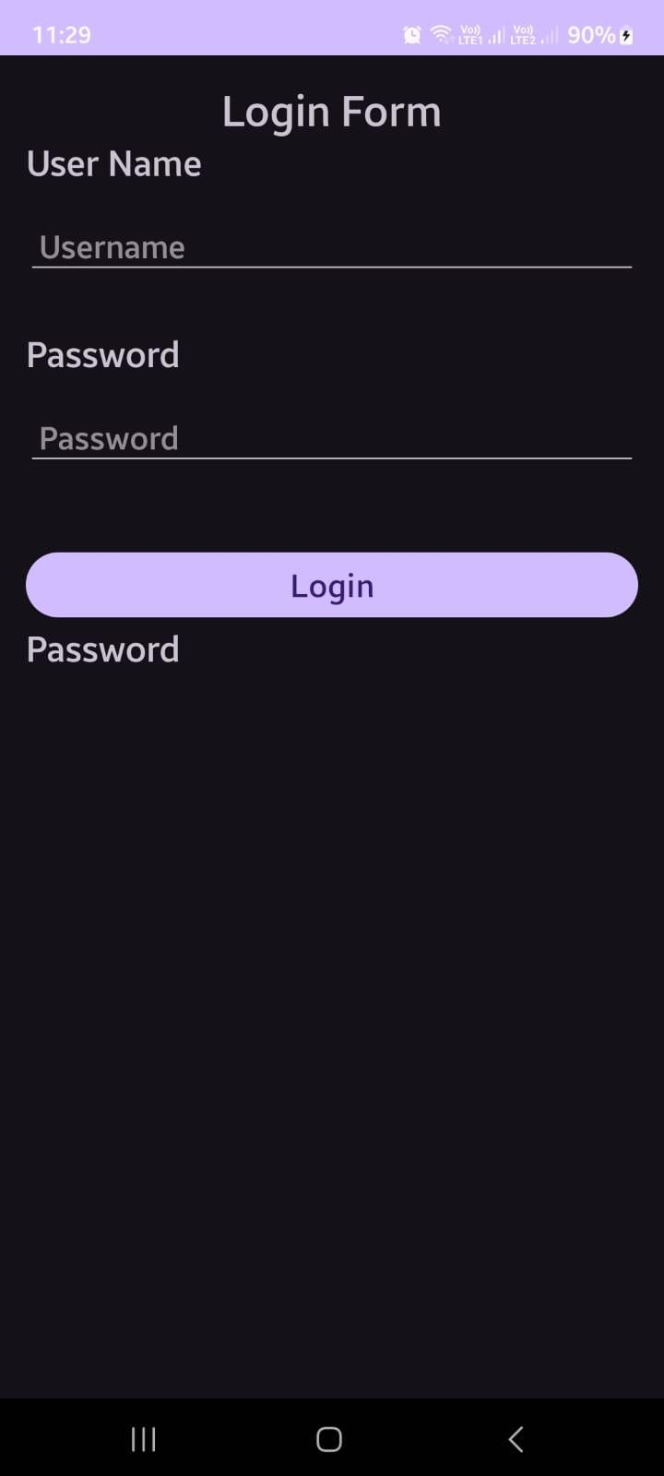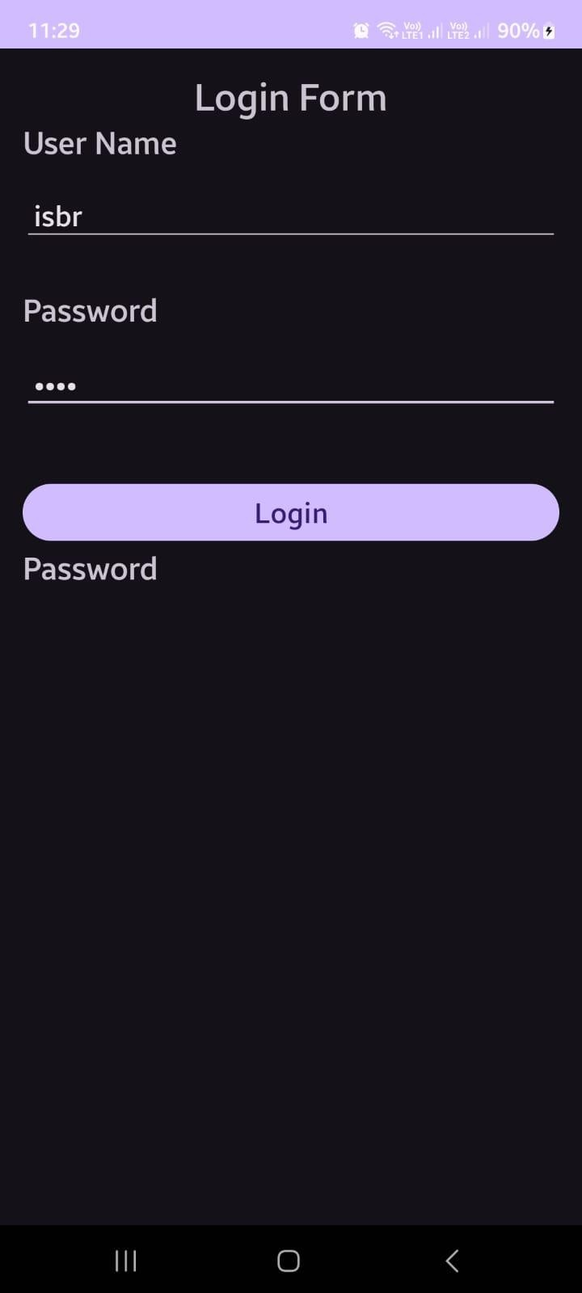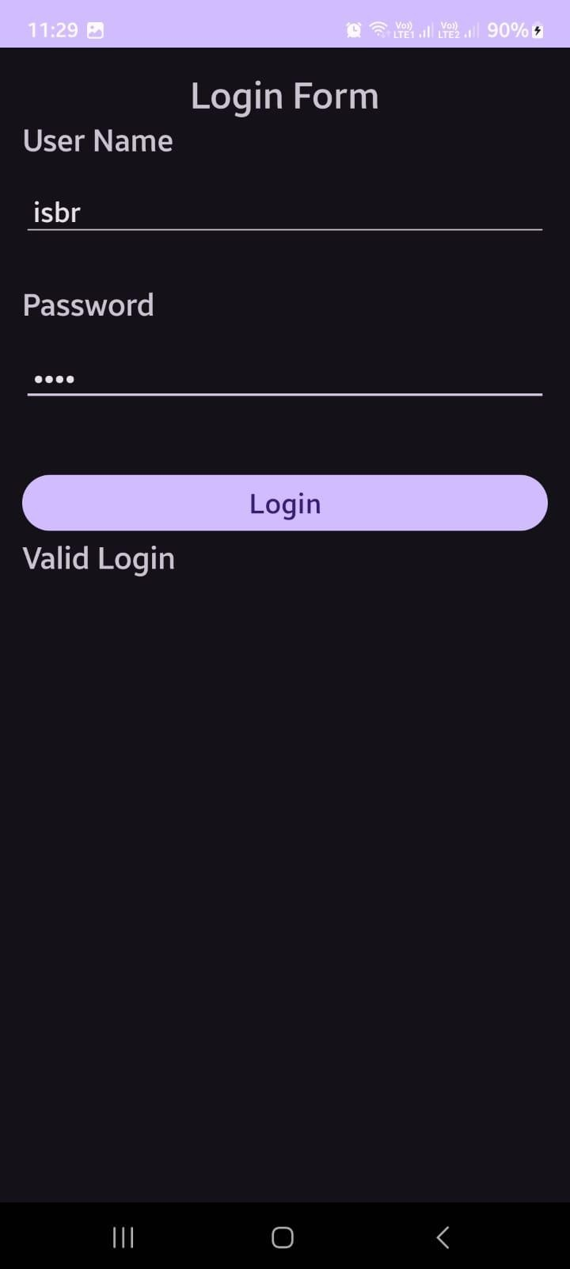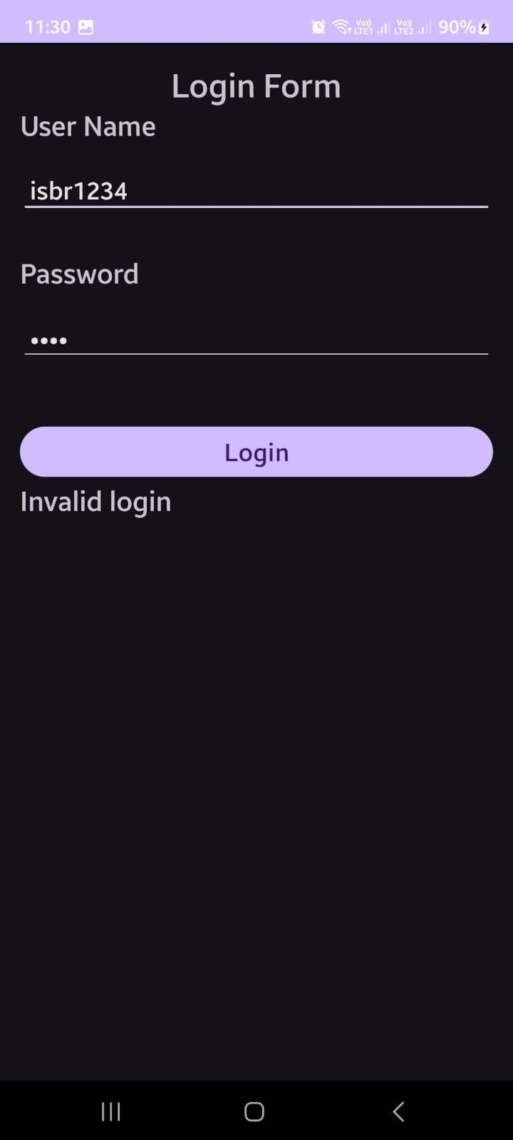

**Program 14:**

Learn to deploy Android applications

# Steps to Deploy an Android Application

**1.Prepare App** (use Program 1 Hello world for this program)

* + Optimize performance and test thoroughly.
* Ensure compatibility with various devices.

# activity_main.xml

<?xml version="1.0" encoding="utf8"?>

<androidx.constraintlayout.widget.ConstraintLayout xmlns:android="[http://schemas.android.com/apk/res/android"](http://schemas.android.com/apk/res/android) xmlns:app="<http://schemas.android.com/apk/resauto>" xmlns:tools="<http://schemas.android.com/tools>" android:layout_width="match_parent" android:layout_height="match_parent" tools:context=".MainActivity">

<TextView   
android:layout_width="wrap_content" android:layout_height="wrap_content" android:text="HelloWorld!"

app:layout_constraintBottom_toBottomOf="parent”  
 app:layout_constraintEnd_toEndOf="parent"  
 app:layout_constraintStart_toStartOf="parent”  
 app:layout_constraintTop_toTopOf="parent"  
 android:textSize="30sp"/>  
</androidx.constraintlayout.widget.ConstraintLayout>

# MainActivity.java

package com.bca.helloworld;

import androidx.appcompat.app.AppCompatActivity; import android.os.Bundle;

public class MainActivity extends AppCompatActivity

{

protected void onCreate(Bundle savedInstanceState)

{

super.onCreate(savedInstanceState);

setContentView(R.layout.*activity_main*);

}

}

# Generate Signed APK (Android Package Kit):

* + In Android Studio, navigate to Build > Generate Signed Bundle/APK.
  + Follow the prompts to create a new keystore or use an existing one. A keystore is a binary file that contains a set of private keys.
  + Configure the build type (release) and signing configuration.
  + Generate the signed APK file.

# Test Your Signed APK:

* + Before distributing your app, test the signed APK to ensure that the signing process didn't introduce any issues.
  + Install the APK on various devices and perform thorough testing.
  + Release on Google Play Console:
  + Sign in to the Google Play Console (https://play.google.com/apps/publish).
  + Create a new app entry if this is your first release or select an existing app.
  + Complete all the required information for the app listing, including the title, description, screenshots, and categorization.
  + Upload your signed APK file.
  + Set pricing and distribution options.
  + Optimize your store listing for search and conversion.
  + Once everything is set, click the "Publish" button to release your app to the Google Play Store.

# Other Distribution Channels (Optional):

* + Besides Google Play, you can distribute your app through other channels such as Amazon Appstore, Samsung Galaxy Store, or thirdparty app marketplaces.
  + Each distribution channel may have its own requirements and submission process, so be sure to follow their guidelines.

# Monitor and Update:

* + Keep an eye on user feedback and app performance metrics through the Google Play Console.
  + Regularly update your app to fix bugs, add new features, and improve user experience based on feedback.